Short-Answer-Essay: Villain Representation
Name: Date:

Writing an essay aka building a burger

Think about a hamburger for a moment. What are its three main components?
There's a bun on top and a bun on the bottom. In the middle, you'll find the hamburger itself. So what does that have to do with an essay? Think of it this way:

- The top bun contains your introduction and thesis statement. This paragraph begins with a hook, or factual statement intended to grab the reader's attention. It is followed by a thesis statement, an assertion that you intend to prove in the body of the essay that follows.

- The meat in the middle, called the body of the essay, is where you'll offer evidence in support of your topic or thesis. It should be three to five paragraphs in length, with each offering a main idea that is backed up by two or three statements of support.

- The bottom bun is the conclusion, which sums up the arguments you've made in the body of the essay.

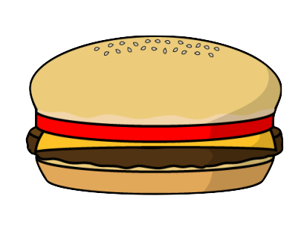

Like the two pieces of a hamburger bun, the introduction and conclusion should be similar in tone, brief enough to convey your topic but substantial enough to frame the issue that you'll articulate in the meat, or body of the essay.

So how to go about it?
When making a burger, would you start by putting the top bun (aka introduction) on your plate? Probably not. Believe it or not, the best way to start your essay is by coming up with a thesis statement (what is this essay about? What point do you want to make/ prove?) Once you have your thesis statement, start by writing your body paragraphs (aka cook your pattie) followed by the conclusion. Then go back and come up with a good introduction that suits the rest of the essay.
Planning for your essay:

Thesis Statement: (What argument do I want to raise in this essay?)
Example: “A zebra is a type of mammal is covered with hair/fur, it is warm-blooded, and breaths through lungs.”

BODY PARAGRAPHS:

1. Brainstorm what you’d like to put in the paragraph before you start writing.

- “What exactly am I trying to say with this paragraph?”
- “What’s the best evidence I have to support my point?”
- “How does the information in this paragraph connect to the question I’m trying to answer or the main point I’m trying to make?”

2. Start with a topic sentence (T). The T in TEEL stands for “Topic.” The topic sentence introduces the main idea of your paragraph or summarizes the argument you are trying to make. The topic sentence usually comes first in the paragraph.
- Keep your topic sentence clear and concise, so that the reader can tell exactly what the paragraph is about. Refer back to your thesis.
- For example, your topic sentence might be “A zebra is a type of mammal because it is covered with fur.”

3. Provide an explanation (E). Next, provide 1 or 2 sentences explaining or elaborating on the topic. These sentences might provide context, clarify the meaning of the topic sentence, or go into more detail about the point(s) raised in the topic sentence.
- For example, your explanation might state, “Mammals have guard hair which keeps moisture and underfur which acts as an insulating blanket that keeps the animal warm.”
- In media: when using SWAT codes in your evidence, do not just note them down but explain how the specific code helps to justify your arguement

4. Back it up with an example or evidence (E). To support your topic, provide relevant examples or evidence. This will help show that your argument is credible. The second E in TEEL can stand for either “Example” or “Evidence.”
- For instance, in your paragraph about zebras, you could follow up your explanation by saying, “Like with all mammals, the fur of zebras has many uses: protection, sensory purposes, waterproofing, with the primary usage being thermoregulation.”
- You might have several examples or pieces of evidence to choose from. Try to pick the example or evidence that is most relevant and best supports your argument.

5. Wrap up with a link (L) to your main argument. The L in TEEL stands for “Link.” The final sentence of the TEEL paragraph puts your paragraph in context by connecting it to another idea. For example, you might use this sentence to summarize the argument of the paragraph itself, to link to the main argument of your essay, or to connect this paragraph to the next one.
- For example, you might sum up your paragraph on the zebra by saying, “Therefore, the zebra meets all a major criteria for being classified as a mammal.”

Paragraph #1:

T:

E:

E:

L:

Paragraph #2:

T:

E:

E:

L:

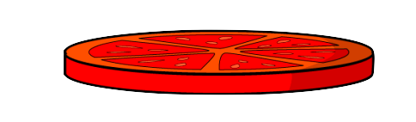
Paragraph #3:

T:

E:

E:

L:

Conclusion:
- Restate the thesis by making the same point with other words (paraphrase).
- Review your supporting ideas.
- For that, summarize all arguments by paraphrasing how you proved the thesis.

Introduction:
- Catch your reader’s attention and interest.
- Give context and background on your topic, but keep it short and simple.
- Set up the focus and purpose of your essay.

Last few steps:

- Read over your essay and check whether it is cohesive. Do all paragraphs link together?
- Check whether all body paragraphs includes the evidence you wanted to give.
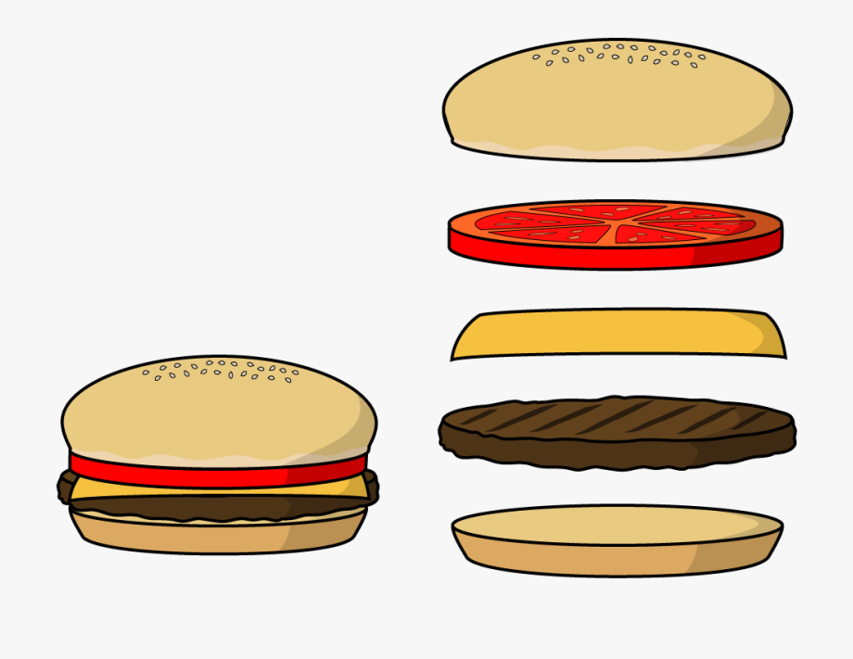
- Make sure to elaborate on examples/evidence and not just give them.

