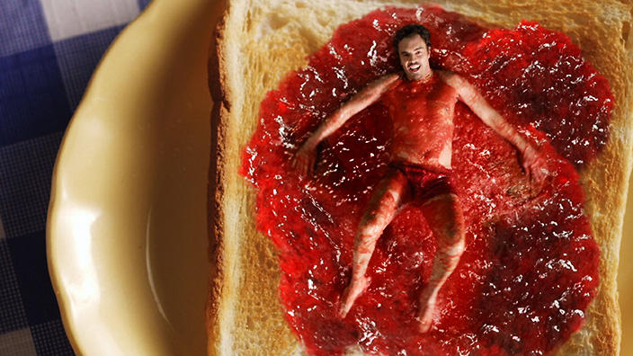
A CASE STUDY
FACTS:
Australia, 2017
Genre:
Language: English
Director: Damon Gameau
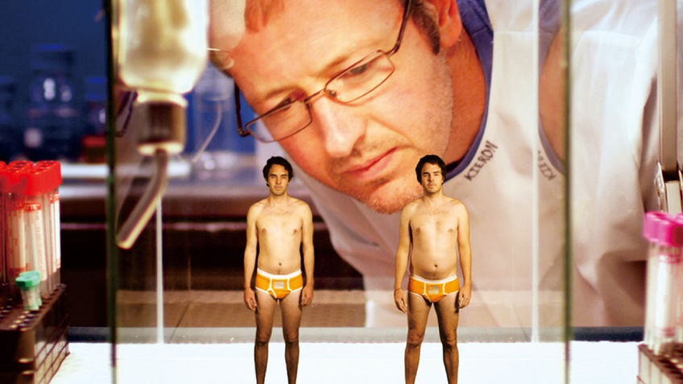
What's it about?
Close your eyes and imagine sugar. What comes to mind? Chocolate, jelly beans, cotton candy, cakes, and ice cream. What about fruit smoothies, baked beans, granola, apple juice? Sugar lurks everywhere in our modern culture. Australian actor and first-time feature documentary director Damon Gameau scares sugar out of its many hiding places and dispels the myths about this pervasive and addictive substance in THAT SUGAR FILM. Having spent the most recent 3 years of his life in a sugar-free state and awaiting the birth of his first child, Gameau contemplates the effects a more “average person diet” would have on his body and mind. Compiling a team of doctors, scientists, and other health-related specialists, he decides to eat 40 teaspoons of sugar per day for 60 days - the amount an average Australian consumes on a daily basis. Gameau doesn’t throw back milkshakes, candy bars, cookies, and slabs of velvety rich cake. He ascribes to what is perceived as a “healthy” diet, packed with kid’s cereals, teriyaki smothered chicken, and low-fat yogurt, and snack bars, eating as many if not less calories than before. Beginning in his homeland, he watches as the pounds pile on and then travels to the U.S., the bulging birthplace of sugar-fuelled obesity, where he witnesses the state of play in the sweet mecca of the world, rotten teeth and all. Upon completion of his 60 days, Gameau is a heavier, unhealthier, crankier version of his former self, and anxiously returns to his sugar-free ways. This saccharine-powered story, full of scientific facts, is made all the more digestible through humour and role playing, resulting in 90 minutes of seductive viewing, encouraging us all - healthy or not - to reflect on our own relationship with the sweet stuff.

Genre Codes and Conventions:
Eg:
Expert opinion:
- Interviews and check-ups with experts
– experts appear frequently, even in fictional parts
-his team has unique names to add humour, eg. “The Crusader, Professor Blood”

Ideas, Attitude, Values
What is the main idea of the film:

What is the subject’s (Damon Gameau) attitude towards sugar and does his attitude change throughout the documentary?

Who do you think is the intended audience? Why?

PESH-Values:
What is a value? Values are basic and fundamental beliefs that guide or motivate attitudes or actions.

Political values in the documentary
A political value is something you believe in that relates to how government, institutions, organizations should operate, whom it should serve or not serve, who pays for it and who benefits.
Did you detect any Political values in the documentary?

What was said about governmental guidelines when it comes to food packaging?

Economical Values:
Economic value can be described as a measure of the benefit from a good or service to an economic agent.
Did you detect any economical values in the documentary?

What was said about the sugar industry in the documentary?

Social Values:
Social values are a set of moral principles defined by society dynamics, institutions, traditions and cultural beliefs. These values are implicit guidelines that provide orientation to individuals and corporations to conduct themselves properly within a social system.

Did you detect an social values in the documentary?

Historical Values:
Measure of the importance of a document (record) that justifies its permanent retention.
Did you detect any?

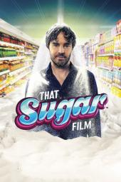

Stylistic elements:

If you had to put “That Sugar Film” into a genre category,
which would you choose? Why?

List the comedic elements that you detected in the film:

List the fictional elements that you detected in the film:

Discuss your initial reaction to the film. Did you find the evidence and format in which the film was presented to be compelling and convincing, or was the comical approach dissuading?

Did the documentary make you reflect on your personal sugar intake? Why do you think that is? What convinced you to reflect?

