Year 8 Gifted and Talented: Media Arts

2023 Course Outline
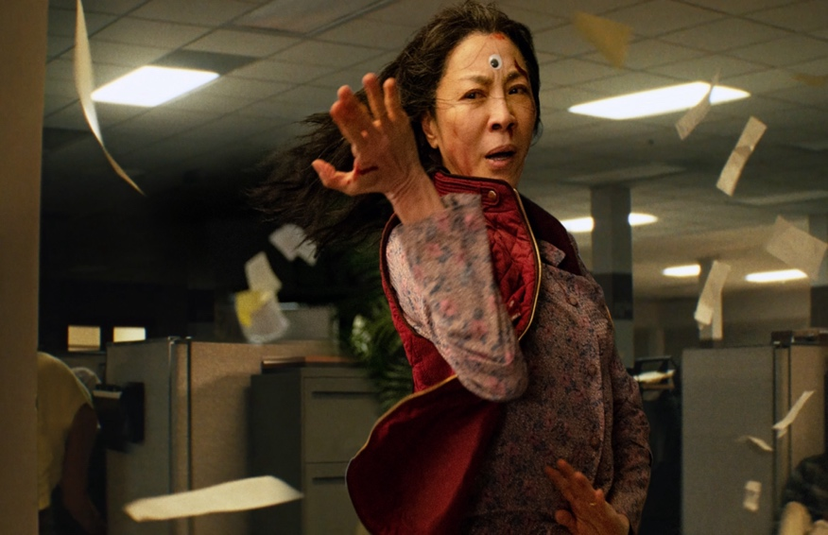
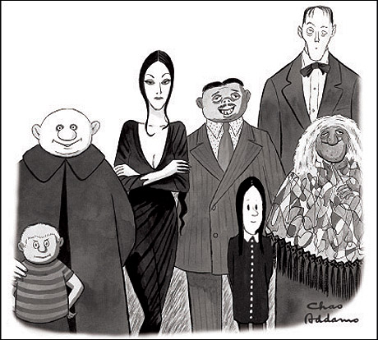
Ms. Jemima Dove

Rationale

The Media Arts GAT course brings together differentiation, depth, density and difficulty as a key element of gifted and talented education. At all times these challenges students’ to articulate creative thinking as a foundational to media theory and production. Opportunities to engage in accelerated and compacted learning within the curriculum over the course of the year.
This subject specifically:
- Accommodates the differing learning styles and rates of students by allowing them to work either singly or in groups, negotiate their own projects within the parameters of the tasks set and organize their own work schedule within the overall time periods allowed.
- Provide students with the opportunity to relate theory and practice in video and radio production and still image manipulation.
- Help students relate what they study at school to possible future employment through industry simulations.

Organisation of content
As part of differentiating the Gifted and Talented program. We have backward mapped the year 12 WACE Media Production & Analysis course and our Year 8 students will be exploring the following key terms, concepts and skills:
In Year 8, students are provided with opportunities to view media work opportunities to view media work from contemporary and past times and to explore viewpoints from Australian, Asian and international media work. Students build on media concepts from previous years, through expansion of the basic communication model to include new and emerging media technologies. They apply their understanding of intended audience, purpose and context in their productions and in their response to their own and others’ media work. They explore current trends in how audiences use media.
Students begin to solve problems, work as a team, follow timelines and use processes and strategies to ensure safe and responsible use of media equipment.
Students are expected to work within, or across, the following media in each year level: film, television, photography, print media, radio or online media.
As part of differentiating the Gifted and Talented program. We have backward mapped the year 12 WACE Media Production & Analysis course and our Year 8 students have opportunity to explore the following key terms, concepts and skills:
- System of Communication
- Genre
- Narrative Elements – characters, setting, conflict, resolution and themes
- Codes and conventions
- Representations
- Intended Audience
- Preferred Meaning
- Technologies
- International Popular Media
- Commercial Media
- Stars and Celebrities
- Audience’s Social practices and Cultural Experiences
- Production Context Controls-
- Classification, Copyright & Censorship

* NOTE: Production tasks run concurrently with response tasks and will be balanced in terms of number of classroom hours provided.

*** Please note that these are subject to change based on context and content.
Assessment  task  weighting | Start and  submission date | Assessment type | Assessment task
N/A | Term 1  Week 1–3 | Response | Task 1: Pre-Test Image Analysis SWAT/CCRS
N/A | Term 1  Week 1–3 | Production | Task 2A: Promotional Short Film: Sell My Suburb Mood board and Pitch
20% | Term 1  Week 5-10 | Production | Task 2B: Promotional Short Film: Sell My Suburb
5% | Term 1  Week 10 | Production | Task 2C: Promotional Short Film Reflection and Viewing
12.5% | Term 2  Week 1-3 | Response | Task 3: Day in the Life Short Film: Analysis
N/A | Term 2  Week 4 | Production | Task 4A: Day in the Life Short Film Mood Board and Pitch
20% | Term 3  Weeks 5 | Production | Task 4B: Day in the Life Short Film Production
5% | Term 3  Week 6 | Production | Task 4C Day in the Life Short Film Reflection and Viewing
12.5% | Term 3  Week 5-6 | Response | Task 5: Action-Adventure Film Analysis
N/A | Term 3  Week 5 | Production | Task 6A: Action-Adventure Mood Board and Pitch
20% | Term 3  Weeks 5-10 | Production | Task 6B: Action-Adventure Film Production
5% | Term 3  Weeks 10 | Production | Task 6C: Action-Adventure reflection and Viewing
N/A | Term 4  Weeks 1-3 | Response | Task 7: Video Game Analysis of PESH-V
N/A | Term 4  Week 4 | Production | Task 8A: Video Game Concept: World Building Planning
N/A | Term 4  Week 5-9 | Production | Task 8B: Video Game Concept: World Building
N/A | Term 4  Week 10 | Response | Task 8C: Video Game: World Building reflection
100% | 70% Production 30% Response

Course outline

Note: Some tasks overlap other task time frames. This is to allow for concurrent assessments, such as one response task and a production task at the same time.
Week | Tasks and activities |  |  | Checkpoint
Term 1 Week 1 | Get to know you. Holiday Pictionary. Course outline  Content - Media Language, Audiences, Production Outcomes  Narrative, codes and conventions  - narrative structures  - narrative elements in different genres and styles, including characters, settings, conflicts, resolutions  - codes and conventions used to construct meaning  Representation  - the process of constructing representations  - linking representations to the values of mainstream audiences  - the effects of using stereotypes  Audience  - how mainstream audience values inform media work  - how meaning is encoded by the producer and decoded by audiences  Ideas and reflective practice  - investigating and analysing examples of media work |  |  | - Assessment outline  - Assessment program
Week 2 | Narrative, codes and conventions  - How media work is constructed to convey preferred meanings, themes, values and point of view  Audience  - how cultural context and audience values influence the interpretation of media work  - the interrelationship between producers and audiences  System of communication  - expectations of particular media  - relationship between media, popular culture and context  - trends in media use, genres and/or styles  Representation  - representation of groups, places, events and ideas  - how values shape representations  Ideas and reflective practice  - investigating and analysing examples of media work  Skills and processes  - applying production skills  - knowledge and application of safety procedures
Week 3 | Narrative, codes and conventions  - use of narrative in journalistic or influential media work  - codes and conventions to construct realism in journalistic or influential media work  - how media work is constructed to convey preferred meanings, themes, values and point of view  Purpose and content  - producing purposeful and/or influential content  - using codes and conventions to convey theme, genre, style and narrative |  |  | Task 1: Promotional Video Analysis  Task 2A: Promotional Short Film: Sell My Suburb Mood board and Pitch
Week 4 | Representation  - representation of groups, places, events and ideas  - how values shape representations  - selection processes, including sources of information, style, selection, omission and emphasis  Skills and processes  - applying production skills  - knowledge and application of safety procedures
Week 5 | Skills and processes  - applying production skills (independent management of time and technologies, management of team members, negotiating and adapting production processes, identifying problems and applying appropriate solutions) |  |  | Task 2A: Promotional Short Film: Sell My Suburb Mood board and Pitch DUE
Week 6 | Skills and processes  - applying production skills (independent management of time and technologies, management of team members, negotiating and adapting production processes, identifying problems and applying appropriate solutions) |  |  | Task 2B: Promotional Short Film: Sell My Suburb
Week 7 | Skills and processes  - fulfilling defined production roles  - implementing production processes based on proposals, scripts and plans
Week 8 | Skills and processes  - using conventional genres, styles and conventions
Week 9 | Skills and processes  - using conventional genres, styles and conventions
Week 10 | Skills and processes  - reflecting on the production process  - evaluating own and others’ productions (peer and/or professional) |  |  | Task 2C: Promotional Short Film Reflection and Viewing
Term 1 Break

Week |  | Tasks and activities | Checkpoint
Term 2 Week 1 | Narrative, codes and conventions  - use of narrative in journalistic or influential media work  - codes and conventions to construct realism in journalistic or influential media work  - how media work is constructed to convey preferred meanings, themes, values and point of view  Audience  - how cultural context and audience values influence the interpretation of media work  - the interrelationship between producers and audiences  Production contexts  - how production contexts influence the point of view of media work  Ideas and reflective practice  - investigating, analysing and evaluating examples of media work |  |  | Task 3: Day in the Life Short Film: Analysis
Week 2 | Representation  - representation of groups, places, events and ideas  - how values shape representations  - selection processes, including sources of information, style, selection, omission and emphasis  Ideas and reflective practice  - investigating, analysing and evaluating examples of media work
Week 3 | Purpose and content  - producing purposeful and/or or influential content  - using codes and conventions to convey theme, genre, style and narrative  Ideas and reflective practice  - investigating, analysing and evaluating examples of media work  - developing proposals and plans  Controls and constraints  - independent management of time, technologies, safety procedures and resources  - negotiating and adapting production processes  - identifying problems and applying appropriate solutions |  |  | Task 3: Day in the Life Short Film: Analysis DUE  Task 4A: Day in the Life Short Film Mood Board and Pitch
Week 4 | Media producers  - the potential freedom of independent media producers  Production contexts  - how production contexts influence the point of view of media work  - ethical issues, accuracy of information and legal consequences
Week 5 | Audience  - how cultural context and audience values influence the interpretation of media work  - the interrelationship between producers and audience |  |  | Task 4A: Day in the Life Short Film Mood Board and Pitch DUE  Task 4B Day in the Life Short Film Production
Week 6 | Purpose and content  - producing purposeful and/or influential content  - using codes and conventions to convey theme, genre, style and narrative
Week 7 | Skills and processes  - applying production skills (independent management of time and technologies, management of team members, negotiating and adapting production processes, identifying problems and applying appropriate solutions)
Week 8 | Skills and processes  - applying production skills (independent management of time and technologies, management of team members, negotiating and adapting production processes, identifying problems and applying appropriate solutions)
Week 9 | Skills and processes  - refining skills within defined production roles
Week 10 | Skills and processes  - reflecting on the production process  - evaluating own and others’ productions (peer and/or professional)

Week | Tasks and Activities | Checkpoint
Term 3  Week 1 | System of communication  - relationship between media, popular culture and context  - trends in media use, genres and/or styles  Narrative, codes and conventions  - narrative structures  - narrative elements in different genres and styles, including characters, settings, conflicts, resolutions  - codes and conventions used to construct meaning  - construction of theme in media work  Representation  - the process of constructing representations  - linking representations to the values of mainstream audiences  - the effects of using stereotypes  Production  Ideas and reflective practice  - evaluating own and others’ productions
Week 2 | Audience  - how mainstream audience values inform media work  - how meaning is encoded by the producer and decoded by audiences  Industry  Media producers  - factors that affect media work produced in a large-scale institution  - the role of media producers in the commercialisation of media work
Week 3 | Narrative, codes and conventions  - narrative elements in different genres and styles, including characters, settings, conflicts, resolutions  codes and conventions used to construct meaning  Production  Ideas and reflective practice  - developing proposals, scripts and plans
Week 4 | Narrative, codes and conventions  - codes and conventions used to construct meaning  - construction of theme in media work | Task 4C: Day in the Life Short Film Reflection and Viewing  Task 5: Action-Adventure Film Analysis
Week 5 | Production  Ideas and reflective practice  - investigating and analysing examples of media work  - developing proposals, scripts and plans | Task 6A Action-Adventure Film Mood Board/Pitch  Task 6B Action-Adventure Film Production
Week 6 | Skills and processes  - applying production skills and processes based on proposals, scripts and plans  - fulfilling defined production roles
Week 7 | Skills and processes  - applying production skills (independent management of time and technologies, management of team members, negotiating and adapting production processes, identifying problems and applying appropriate solutions)
Week 8 | Skills and processes  - fulfilling defined production roles  Purpose and content  - producing purposeful and/or popular culture content  - using codes and conventions to convey theme, genre, style and narrative
Week 9 | Skills and processes  - using conventional genres, styles and technical conventions
Week 10 | Skills and processes  - reflecting on the production process  - evaluating own and others’ productions (peer and/or professional) | Task 6C Action-Adventure Film Production Reflection and Viewing
Week | Tasks and Activities | Checkpoint
Term 4  Week 1 | Audience  - how mainstream audience values inform media work  - how meaning is encoded by the producer and decoded by audiences  - how cultural context and audience values influence the interpretation of media work  Representation  - the process of constructing representations  - linking representations to the values of mainstream audiences  - the effects of using stereotypes  - how values shape representations  Production  Ideas and reflective practice  - investigating and analysing examples of media work | Task 7: Video Game Analysis of PESH-V  ( Formative)
Week 2 | System of communication  - media ownership, sources of revenue and expectations of particular media  - audience reach, immediacy, accessibility and interaction  Media producers  - factors that affect media work produced in a large-scale institution  - the role of media producers in the commercialisation of media work  Production contexts  - the influence of globalisation on media work  - effect of controls and constraints on production
Week 3 | Skills and processes  - applying production skills (independent management of time and technologies, management of team members, negotiating and adapting production processes, identifying problems and applying appropriate solutions) | Task 8A: Video Game Concept: World Building Planning ( Formative)
Week 4 | Skills and processes  - fulfilling defined production roles  - implementing production processes based on proposals, scripts and plans
Week 5 | Skills and processes  - applying production skills (independent management of time and technologies, management of team members, negotiating and adapting production processes, identifying problems and applying appropriate solutions) | Task 8B Video Game Concept: World Building Production ( Formative)
Week 6 | Skills and processes  - applying production skills (independent management of time and technologies, management of team members, negotiating and adapting production processes, identifying problems and applying appropriate solutions)
Week 7 | Skills and processes  - refining skills within defined production roles
Week 8 | Skills and processes  - refining skills within defined production roles
Week 9 | Skills and processes  - reflecting on the production process  - evaluating own and others’ productions (peer and/or professional | Task 8C Video Game Concept: World Building Production Reflection & Exhibition. ( Formative)
Week 10 | Skills and processes  - reflecting on the production process  - evaluating own and others’ productions (peer and/or professional)

